TMFF For Teachers

WHY VISIT TAILOR MADE FISH FARMS & COOKABARRA RESTAURANT?

There are many benefits for schools that choose to visit our farm.

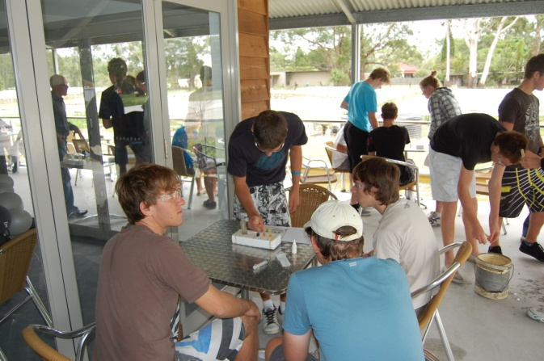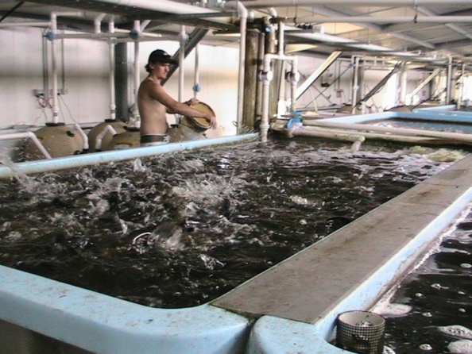
Students benefit by:
- learning that aquaculture is an important part of the seafood industry and their community
- seeing how things they learn about in the classroom can be applied in a real life setting
- meeting workers who can show them first-hand what they do for a living
Teacher benefit by:
- using our facilities to help address specific curriculum outcomes
- professional development; learning first-hand about the aquaculture industry in NSW
- the opportunity to create links with the aquaculture industry
- getting access to up-to-date and locally relevant information on aquaculture

EDUCATIONAL CONTENT
Our School Tour Program is aligned to the curriculum and caters to different stages of learning. ‘The program is relevant to a number of learning areas, as well as the cross-curriculum priority of Sustainability. In particular, it addresses outcomes in:
Human Society and Its Environment (HSIE) | Science & Technology
Geography  (Industry Study) | Hospitality and Food Technology  (Commercial kitchen & Cooking Demonstration)
Agriculture (Industry Study) | Marine Studies
Work Education & Life Skills

Some of the things that visiting students learn about are:
- Where seafood comes from and how it gets to their plate
- How our aquaculture activities are carried out in their local area
- Australia’s fishing resources and how we manage our stock and products, including what we are doing to ensure sustainability
- Types of careers available in the aquaculture industry
- Simple Hydroponics that reinforce School Garden initiatives
The important feature of our farm is that it offers ‘real-life, hands-on learning’, demonstrating to students how knowledge they learn in the classroom (e.g. in Science or Geography) can be applied in an everyday working context.
A visit can be tailored to suit the needs and interests of different groups. For example, your class may be learning about food production methods, how a business is managed, or how sustainability can be applied.

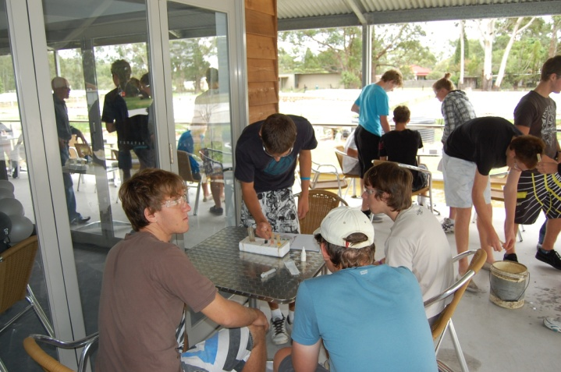
Many Regional and even Metropolitan schools have taken advantage of our ‘farm-to-plate’ learning experiences, and we invite you to contact either
Graeme at (Graeme@tailormadefishfarms.com.au ) or
Maddison at (info@cookabarra.com.au ) for planning a full program during 2015.
Phones – 02 49826600 and 02 49826740

