For Overnight Excursions

-Kookaburra Farmstay is next door to TMFF
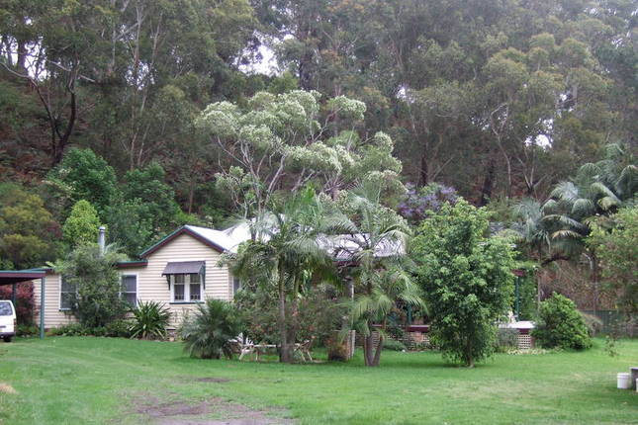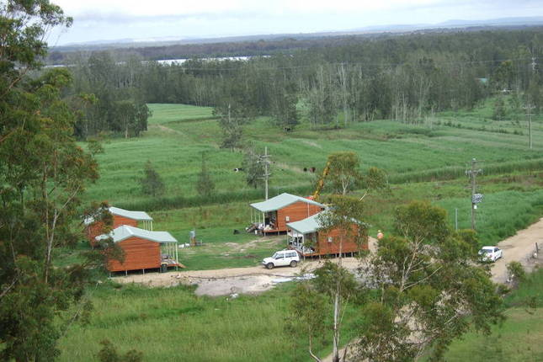

The original homestead and the separate cottages

Description
The Farm offers accommodation for families or couples looking to escape to the privacy of the country while providing access to the beach and Town Centre, both only minutes away. Our 3 bedroom federation farmhouse is fully renovated with large living areas and spacious verandah.
Our 3 bedroom cottages are built of western red cedar and have polished floors and a spa bath. One cottage is disabled friendly with ramp, no steps and open plan bathroom.
All houses have a fire place for winter warmth, are self-contained and linen is available for a small cost, or byo linen.
The farmhouse accommodates up to 30 people and the cottages up to 8 people.
4 new cabins great for small farmilies.
Enjoy farm life and get back to nature, lots to do or just do nothing.
Pet friendly with conditions.

Location
Bobs Farm is 2.5 hours from Sydney and .5 hours from Newcastle. We are situated only 7 minutes to Anna Bay and 15 minutes to Nelson Bay. We are bordered on the north by Tilligerry Creek, and on the south by bush, Stockton sand dunes and the Pacific Ocean.
Kookaburra Cottage Farmstay is located on 35 acres of bush and farm land.

